**Applied Statistics - Lab 5**

**Date of performance:** 16-09-2021

**Date of Submission:** 22-09-2021

**SAP Id:** 500083382

**Name:** Anurag Singh

**Batch:** AI&ML B2

**___________________________________________________________________________**

**Topic: Z-Table and the Area under the curve**

**Problem:**

Import the z table as a data structure in python. Create some 5 demo examples to find the area under the curve and report the answer from the z-table.

**Z-TABLE**

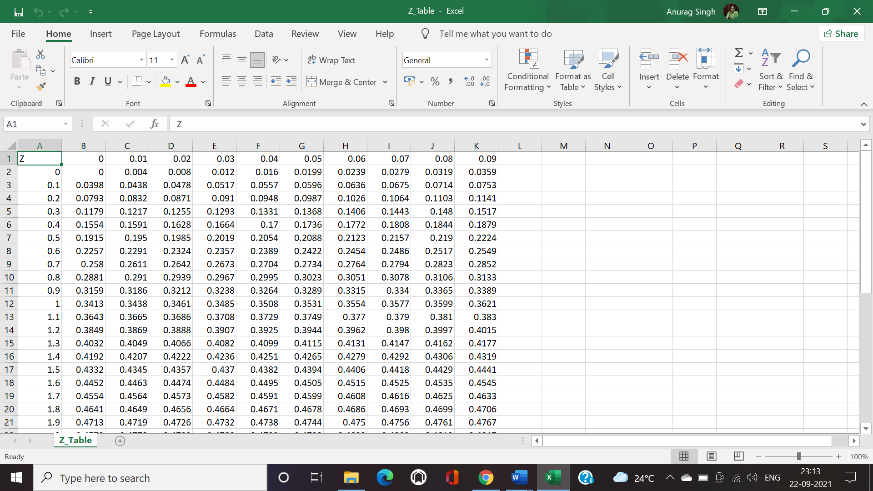

**Code:**

data = np.random.randint(10,100,size=35)

print("ORIGINAL DATA IS:", data)

mean = statistics.mean(data)

stdev = statistics.stdev(data)

z_values=[]

for values in data:

z=(values-mean)/stdev

z={}.format(z)

z_values.append(z)

z_values=list(map(float,z_values))

print("STANDARD NORMALISE DATA IS:")

print(z_values)

print()

for i in range(1,6):

random_variable=random.choice(z_values)

print(random_variable)

row=0

column=0

if (random_variable>0):

column=float({a}.format(a=((random_variable*100)%10)*0.01))

row=float({a}.format(a=random_variable - column))

print(f'column:{column},Row:{row}')

else:

column=float({}.format(-((random_variable*100)%(-10)*0.01))

row=float({a}.format(a=random_variable + column))

print(f'column:{column},Row:{row}')

z=(value-mean)/stdev

z={}.format(z)

z_values.append(z)

z_values=list(map(float,z_values))

print("STANDARD NORMALISED DATA: ")

print(z_values)

print()

for i in range(1,6):

random_variable=random.choice(z_values)

print(random_variable)

row=0

column=0

if (random_variable>0):

column=float({a}.format(a=((random_variable*100)%10)*0.01))

row=float({a}.format(a=random_variable-column))

print(f'column:{column},Row:{row}')

else:

column=float({a}.format(-(a=(random_variable*100)%(-10)*0.01))

row=0

row=float({}.format(random_variable+column))

print(f'column:{column},Row:{row}')

value1=df.loc[df['Z']]==row, str(column)]

value2=1-value1

print(f'P(X<{random_variable})={value1}')

print(f'P(X<{random_variable})={value2}')